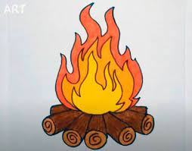

IDEAS AND SUGGESTIONS FOR SERVICES.

These are just some ideas to think about

- Acknowledge the traditional owners of the land or you may say,

“We acknowledge the traditional owners of this land and we pay our respects to their ancestors, past and present.”

- Have a red, black and yellow Sunday. The congregation all comes with something in the colours.

- Congregation wears ribbons of red, black and yellow. Could be supplied at the door for all the congregation to wear as they receive their pew sheets and books.

- Include Aboriginal people in the service as readers, speakers, musicians, dancers, etc

- Use Australian elements in the service such as Eucalyptus oil, tea tree oil, gum leaves and Indigenous symbols and materials around the altar. Perhaps an Aboriginal altar cloth or Aboriginal material on the altar.

- Use an Indigenous prayer during service.

- Use a local Aboriginal story as a reading for the day.

- Use Aboriginal clipart on pew sheets etc,

- Use our Presentation as a reflection during the service.

